**Chart Management Subsystem Functional Requirements, v0.3**

**Author: Josh Trimm**

**Edited by Phil Pfeiffer**

**Last Updated 12 September 2021**

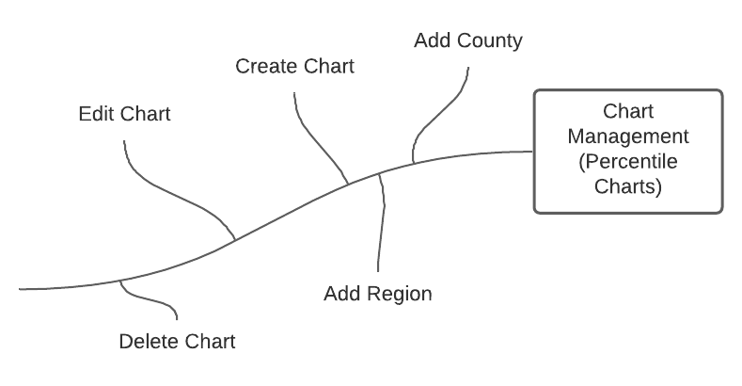

# Functional Requirements

1. The system shall allow Admins and Cartographers to create new charts.
   1. The chart management system shall require ***Chart Creators*** to specify a name for each chart.
      1. This name must differ from the names of all other charts that this system currently stores.
   2. The chart management system shall allow ***Chart Creators*** to select a specific CSV year for the chart’s data.
      1. This year shall default to the current year.
   3. The chart management system shall require ***Chart Creators*** to select a single health indicator for the selected CSV year.
   4. The chart management system shall require ***Chart Creators*** to add either counties and or one region to a chart, but not both.
      1. The chart management system will allow ***Chart Creators*** to add at most one region to a given chart.
   5. The chart management system shall allow ***Chart Creators*** to specify a description for their chart.
      1. This description shall default to the name of the chart’s indicator and the year for which the chart was created
2. The system shall allow ***Chart Creators*** to store the parameters for any chart that they’ve created for subsequent recall, subject to limitations on system storage.
   1. These parameters shall include the chart’s name, year, region/counties, health indicator, and optional description.
   2. All health indicators shall be loaded dynamically from each CSV after the year is chosen.
3. The system shall allow chart creators to edit any the parameters for any chart that they have created.
   1. The system shall allow Admins to edit everyone’s charts.
4. The system shall allow all users to generate charts from stored descriptions, by name
   1. These charts shall be populated dynamically, from data in the specified year’s CSV file.
   2. The chart system shall handle years without CSV files by notifying a user that the specified CSV file is not present.
   3. The chart system shall handle health indicators that are not present in a specified CSV file by notifying a user that the specified CSV file is not present.
   4. The chart system shall handle undefined counties in specific CSV years that are defined in user created regions by
      1. Handling the null values, and
      2. Prompting ***Chart Creators***, informing them of undefined counties in the selected CSV year.
5. The CPH system will allow ***Chart Creators*** to delete a chart.
   1. The system shall allow Admins to delete anyone’s charts.